**Name of module: Building and leading team.**

**By: Mrs. Sabita Sharma, Principal, Govt. Sr. Sec. School Namcheybong.**

**Introduction:**

The word TEAM may be defined as ‘Together Everyone Achieves More’. A school, like any other Institution, requires an effective team. Besides being an instructional head, the school Principal needs to look into administration and other aspects of the school. Forming a team in itself is a task, as it is not enough to just build a team, it needs to be ensured that the team is effective, successful and it has a group of “problem solving people”, who work together with winning expectations. They should have mutual understanding and support each other.

For a school head, it is important to understand the interests, aptitude, integrity, discipline, etc. of each and every staff member before handling them any task. This personal information makes it easy while choosing them to be a part of a team. If a person isn’t interested in the chosen field in a team, he/she may become a liability for the team, rather than an asset. He/she may not understand the mission or objective of the team, may not contribute anything in the forms of ideas, etc. Thus, the team leader of the team may not be able to motivate him/her. Keeping this in mind, the school Principal first needs to prepare a list of all staff members- teaching staff as well as non-teaching. He/she needs to form various teams and also chose a team leader, who leads the team and takes responsibility for its performance and result. Before finalizing the team list, however, the HOI will hold a staff meeting, to give a chance to each person to understand the area of their work, to self-reflect and decide whether he/she is fit to be a part of the allocated team.

**Learning objectives:**

This module enables the learners to understand the importance of individual role in the success of a team. It also provides opportunity to every individual to take leadership role and realize their potential.

**Key words:** Team-work, leadership, personal and professional development, creativity, collaboration, trust, opportunity.

**Introduction**

It is crucial that all the members of a team are comfortable with each other that there is no tension in the group. Each member expresses his/her feeling openly and there is no room for secrets or ulterior motives. Each one participates in discussion making and work allotted. They listen to each other, ask questions, etc. They have civilized disagreement, which is polite and friendly. They understand their roles and personal responsibilities. Though, a team leader leads a team, there inter-dependence among the team members.

A team will work successfully when like- minded people are chosen to be a part of each team. When they can develop complete trust in each another. When they can appreciate personal differences. When there is open communication and constructive feedbacks are provided by members. Performance of the team depends on their loyalty towards their team while getting things done. When team develops through hard work and reaches a productive stage. When, winning becomes the goal. When, members take pride to win (or become successful in the task) every single time. A team is one where members look after each other. They are focussed as well as create a receptive environment for all.

**Core content:**

Team building comprises of a group of activities strategies and tactics to enhance social relations between team members and motivate them to perform better. Thus it becomes crucial on the part of HOI to engage in routine check-ups, acknowledge good work, conduct motivational activities, else teams may fall apart. Team building activities therefore becomes a must to make sure that teams are getting along well; team members understand their roles, responsibilities and are motivated to perform their best. It allows each member to participate. It provides opportunity to introverts who are otherwise followers rather than leaders, to showcase their leadership skill.

Team building activities are fun and a creative way to get the team connected and work together. It helps to energize the team .It ensure personal as well as professional development of team members and encourage engagement.

In order to give first hand idea regarding team-work and success of a team the teachers are shown a short video – Formula 1 race. Here, (video sent in separate attachment), the formula 1 driver is seen stopping his car before his team of mechanics. Each mechanic does its individual allotted work. No one is seen interfering or obstructing others task. Thus, the work of changing tire, etc gets done in less than 1 second. This shows that each one is important in the team; team is successful if each performs their given task to the best of their ability, each cooperate and not interfere or become critical of another team member.

**Activity- 1**

**Paper Plane:**

Paper plane activity can be as much fun for adults to engage in, as it was when we did it as kids. Team are divided into groups of 5-6 people and each team is given an A4 sheet to make paper plane. Teams are challenged to a race (to fly the plane) and the plane that travels the farthest wins. Alternately, challenge can also be for the “best-designed paper plane”. This exercise encourages creativity as the design of the paper plane plays a significant role in its flight.



This activity (game) enables the learners to understand their individual potential. It also provides each member to express and communicate their ideas to the team-work. It leads to personal development

**Exercise: Multiple Choice Questions**

1. Team-work requires -
2. One resourceful person.
3. Input from all members.
4. Participation by only interested people.
5. Non-participation.
6. Activity requires -
7. Input of ideas.
8. Creative thinking.
9. Practicality.
10. All the above.

**Activity-2**

**Blind drawing:**

One team member is chosen and separated from the group. The person goes to the front and is provided with white board and marker. Other team members are given a picture which they look at for one second and is taken back. Now, each member provides one hint to the person in front who is required to draw the image /images being described. Each member can describe the image without using words that give it away.

After a set time limit, the drawing time ends and team members compare the original picture with the drawing. Team members take turns to go forward and draw (different images are provided) until every person gets chance.

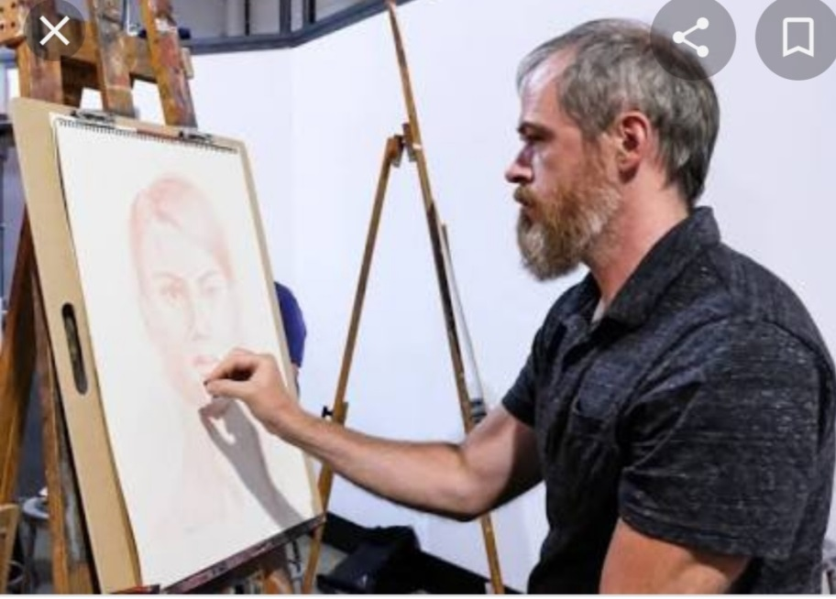

This activity focuses on listening and collaborating skills. The team with the best representation of the image wins.

**Exercise: Multiple Choice Questions:**

1. Activity requires -
2. Memory power.
3. Art of good communication.
4. Ability to express.
5. All the above.
6. Success of team depends on –
7. Individual growth.
8. Collaboration of all team members.
9. Professional growth of individual.
10. Team leader.

**Let’s sum up**

Team building and leading can be a fun way for teachers to get to know each other better and have a great time. It helps strength their relations which in turn leads o success of team and achievement of set goal.

**Team building activities will help to -**

* Bring team closer.
* Encourage creativity.
* Improve communication and collaboration.
* Build sense of trust among team members.
* Improve their morale and confidence.
* Provide each member an opportunity to lead the team.

**Reference:**

1. <https://bit.in-> online Google docs.
2. [www.teaching.com](http://www.teaching.com).
3. www.weareteachers.com.